Data

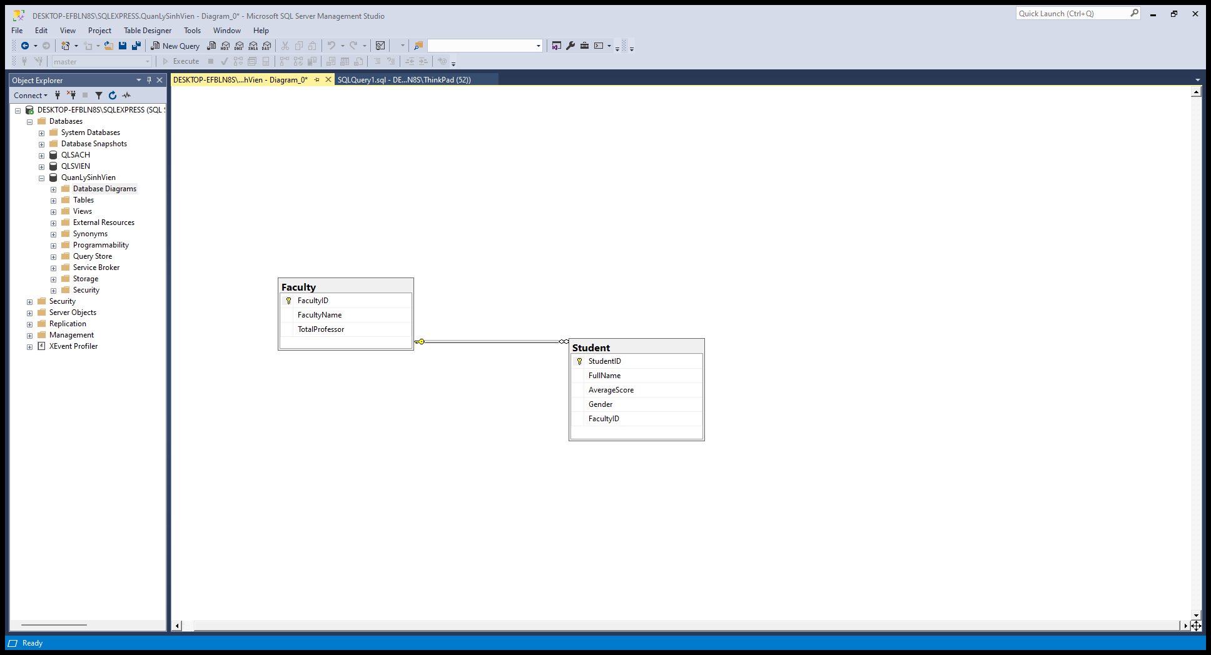

From Sinh viên

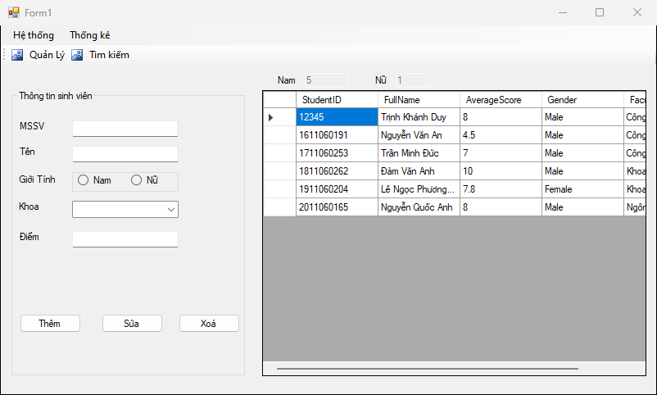

Code Thêm

Code Xóa

Code sửa

From Khoa

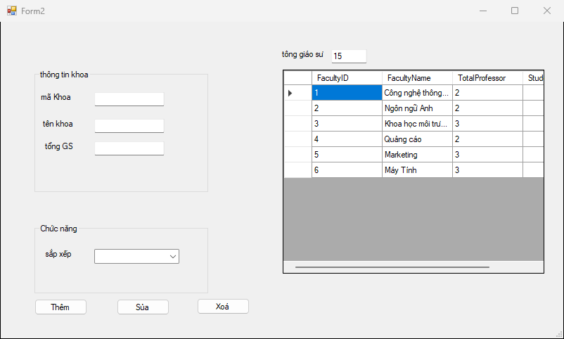

Code Thêm

Code Xóa

Code Sửa

From Tìm kiếm

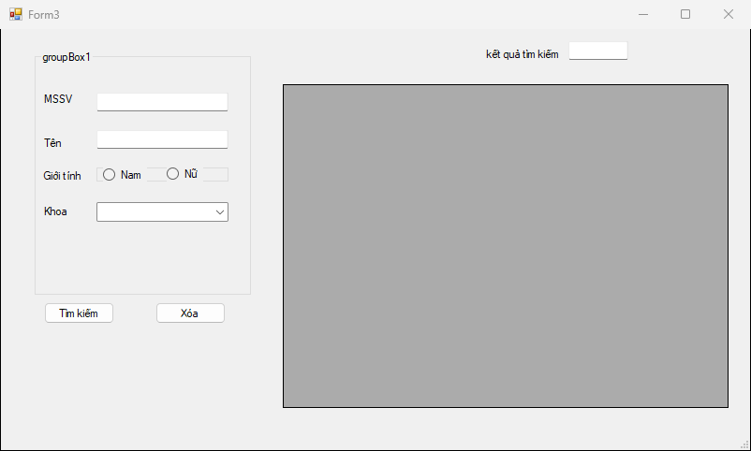

Code Tìm Kiếm

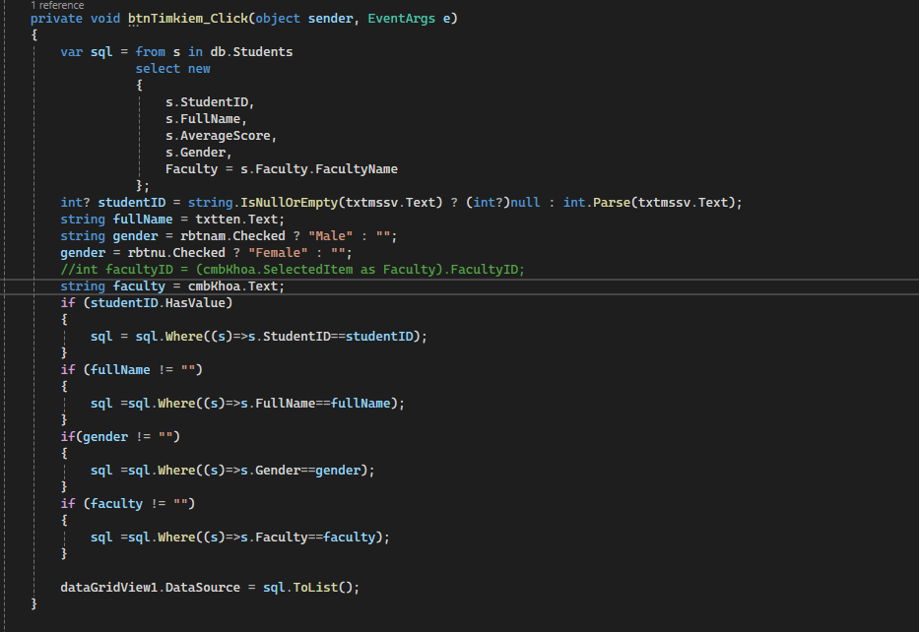

Code Xóa

